04.05.13

Ivanpah plant begins “steam blows”
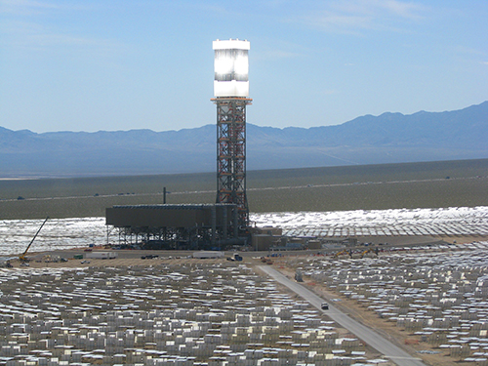
The Ivanpah project recently achieved another milestone! After putting the first flux on the boiler and creating the first steam in late February, the team recently commenced “steam blows.” During steam blows, upwards of thousands of heliostats are focused on the solar boiler to achieve the desired temperatures, pressures and flow rates.
The goal of the steam blows is to clear out any mill scale or debris inside the pipes so it does not damage the steam turbine and other balance of plant equipment once operational. Steam is then distributed to each of the predetermined blow paths, or routes of piping, and released. Targets located inside the pipes are checked to determine the cleanliness factor. The process is repeated until the targets validate that the particulates have been removed.
“Steam blows are a normal start-up process for any conventional steam power plant,” said Mike Bobinecz, Vice President of Construction Management. “This is considered standard industry practice for cleaning steam system circuits.”
Steam blows are part of the “load ascension” program, which includes focusing an increasing number of heliostats onto the boiler and methodically raising the temperature and pressure of the steam produced. Throughout the plant start-up process, the team monitors and tests the plant’s equipment to ensure it is operating properly and safely. Once the steam blows are complete, the team will remove the temporary steam blow piping and reconnect the piping to design conditions. The next step will be for the boiler to admit steam to the steam turbine. Once the steam turbine generator is synchronized to the grid, the plant will generate electricity to the grid.

